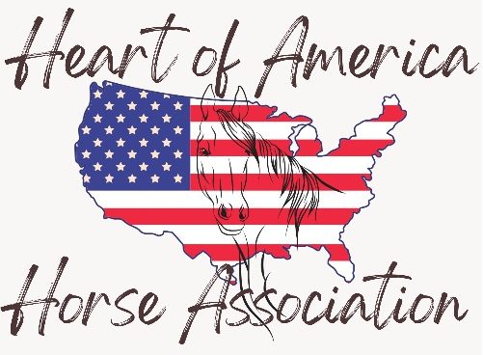

How do I earn a show high point award in 2026?
1. Become a member!!
2. Show in a MINIMUM of 3 performance classes across 1 breed and age division (divisions are listed on the website)
3. All arounds will be available at each of our shows. March, April and August (VRH only).
4. We will NOT have cumulative year end high point awards in 2026. Come show with us and earn awards at each show!

